Intro to Programming (Python)

Assignment 04

# Overview

In this activity, you learn to work with For loops and lists by creating your own script and documenting your knowledge. Your documents so make your document and code look professional.

This assignment includes the following tasks:

1. Watch the module videos.
2. Read a book chapter
3. Review web pages.
4. Watch additional videos.
5. Apply your knowledge.
6. Document your knowledge.
7. Submit your work.

**Tip:** Consider the following questions while you work through the module to help you focus:

* What is a collection of data?
* What is another word for a collection in Python?
* A String is a collection of what?
* How do you access individual values in a String?
* A Tuple is a collection of what?
* How do you access individual values in a Tuple?
* A List is a collection of what?
* How do you access individual values in a List?
* How do you write data from a String into a text file?
* How do you write data from a List into a text file?

# Assignment Steps

The following assignment steps ask you to read about, perform, and write about programming.

***Note:*** *Course assignments help you learn through* ***reading****,* ***watching*** *demonstrations,* ***performing*** *programming in Python, and reflecting on what you learned through* ***writing****. You are strongly encouraged to continue your learning by experimentation.*

## Step 1 - Watch my Video Lecture

Please watch my course lecture for this module. You can find this module lecture(s) here: [ITFdn 110 - Python Course Videos](https://youtube.com/playlist?list=PLfycUyp06LG9fZllIqBrxLcNV4CR50HEX)

## Step 2 - Read a book chapter

Please **read chapter four** in your textbook. You **do not have to perform the exercises or type in the code**, but it is best if you open the script files as you read about them. You can find the downloadable **book files** **on Canvas** for your convenience.

## Step 3 - Web pages

Please review the following web pages. These are shorter than the book and provide online resources you can use later.

1. <https://www.tutorialspoint.com/python/python_strings.htm> (external site)
2. <http://www.tutorialspoint.com/python/python_tuples.htm> (external site)
3. <https://www.tutorialspoint.com/python/python_loops.htm> (external site)
4. <http://www.tutorialspoint.com/python/python_files_io.htm> (external site)

## Step 4 - Additional Videos

Please watch this video. It will explain things a bit differently, which helps with learning!

[Intro to Python - Lists and Tuples](https://youtu.be/UiSEQPLh700) (external site)

## Step 5 - Apply your knowledge

Now that you have reviewed the websites and videos, create a new program that asks the user for the name of a household item, and then asks for its estimated value. Store both pieces of data in a two-dimensional list, where each item and price are a row of data, and each row is part of a table of data.

|  |  |
| --- | --- |
| Lamp | 30 |
| End Table | 100 |

Table 1. Household Items

Continue to ask the user for more data until they ask to exit the program. Allow the user to see the current data collected. When the user exits the program, save the data before they exit in a text file called "HomeInventory.txt." Use a printed "menu" to guide the user through this process.

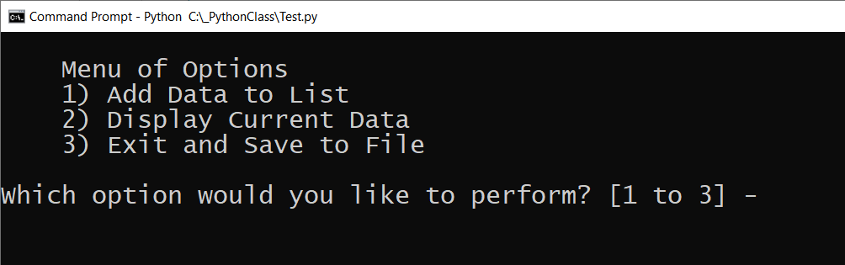

Figure 1. The menu for assignment 4

Here is some Pseudo code to help you get started.

*# Step 1  
# Display a menu of choices to the user*

*# ("Add Data to List", "Display Current Data", "Exit and Save to File")   
  
# Step 2  
# Add a new item to the List(Table) each time the user makes that choice*

*# Step 3  
# Display the data in the List(Table) each time the user makes that choice*

*# Step 4  
# Exit the program and save the data to a text file when the user makes that choice*

### Step 5.1 Create a Folder

Create a **new sub-folder** **called Assignment04** inside of the **_PythonClass** **folder** (you created this in Module 01). Please use the C: Drive on a Windows OS or the Documents folder on a Mac OS (using the Desktop on either OS is not recommend).

### Step 5.2 Create a new Project in PyCharm

Create a new project in PyCharm that uses the _PythonClass\Assignment04 folder as its location.

### Step 5.3 Create a Python Script

Create a python script file within your project called "HomeInventory.py."

### Step 5.3 Add Code to the Script

Add code to your script that will perform that assignment’s task. I suggest you start by adding the header and some pseudo-code.

### Step 5.4 Run Your Script

With the script created in its proper location, run the script in **BOTH** PyCharm and an OS command/shell window and capture images of it working on your computer. Your image should look similar to Figure 2, but it does not have to be precisely like it.

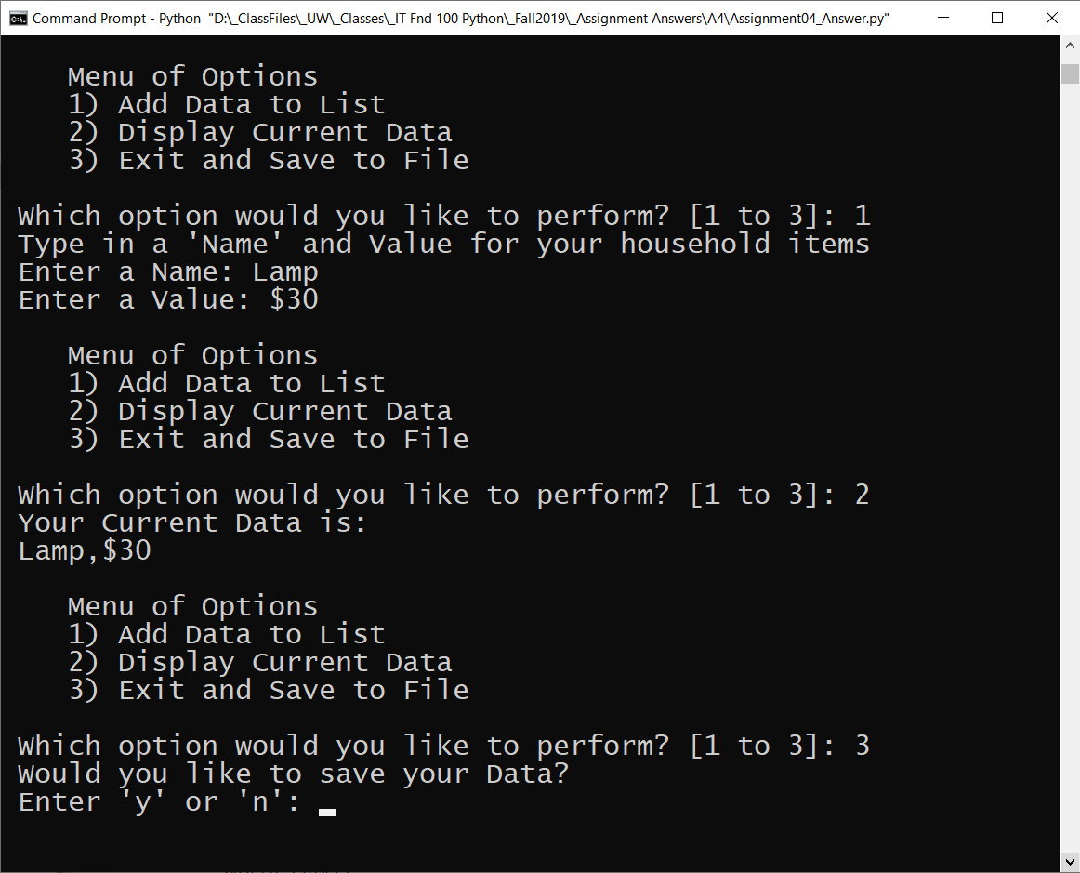

Figure 5: A screenshot of the script running in a command window

### Step 5.5 Verify that it Worked

Locate the text file and open it in a text editor (Figure 3).

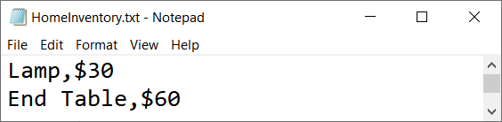

Figure 3: Verifying that the file has data

## Step 6 - Document your knowledge

After you have created and tested your Python script, create a document **describing the steps you took in performing this assignment**. Use screenshots and code samples to explain the process, just as was done in your book, my programming notes, and the web pages you reviewed. Make sure the document is in a pdf file.

## Step 7 - Submit your work

Now place your document with the python script in the Assignment04 folder. Zip this folder into a “.zip” file, then upload the file to the class assignment page.

Congratulations! You are done!